Academic Chemistry Final 2015

Study Guide

Academic Chemistry Final:

38 Multiple Choice Questions UPDATE

18 Short Answer/Calculations

Resources for the final exam
- You will be given a periodic table/ion chart and a formula sheet of equations.

Formula Sheet:

R = .0821 _{L • atm}
^{mol • K} 22.4L in 1 mole at STP

PV = nRT STP = 273K and 1 atm

P₁V₁ = P₂V₂ Molarity = mol
T₁ T₂ L

1 L = 1000 mL pH = -log [H⁺]

1 atm = 760 mmHg M_{A}V_{A} = M_{B}V_{B}

1 atm = 101.3 kPa

Chapter 10: Stoichiometry

Vocabulary

- law of conservation of matter
- molar ratios

Be able to….

- Determine molar ratios

Practice Problems:
- Use the following balanced equation to answer questions

2Al₂(CO₃)₃ + 3H₂SO₄ 2Al₂(SO₄)₃ + 3 H₂O + 3CO₂

  - _________ What is the molar ratio for Al₂(CO₃)₃ and H₂O?

  - _________ How many moles of CO₂ are produced when 3 moles of H₂SO₄ react?

  - _________ How many grams of H₂O are produced when 2.0g of H₂SO₄ reacts?

Chapter 11: Heat & Energy

Vocabulary

- heat

  - temperature

Be able to….

- Identify exothermic vs endothermic reactions.
- Compare sources of energy for transportation, electricity, and heating.

Practice Problems:
2. Label each example as exothermic or endothermic
- 2H2(g) + O2(g) → 2H2O(g) ΔH°= -243 kJ ___________________
- H2B4O7(s) → B2O3(s) + H2O(l) feels warm ___________________
- H2B4O7(s) + H2O(l) → 4HBO2(aq) + 11.3 kJ ___________________

Sources of energy:
- What is the most common source of energy for transportation? ___________________________
What are three alternatives?
______________________________________________________________________________________________________________________________________________________
Which do you think is best? Explain two reasons: ______________________________________________________________________________________________________________________________________________________

- What is the most common source of energy for electricity? ______________________________
What are three alternatives?
______________________________________________________________________________________________________________________________________________________
Which do you think is best? Explain two reasons: ______________________________________________________________________________________________________________________________________________________

- What is the most common source of energy for home heating?____________________________

What are three alternatives?
______________________________________________________________________________________________________________________________________________________
Which do you think is best? Explain two reasons: ____________________________________________________________________________________________________________________________________________________________

Chapter 12: Gases

Vocab:

- Kinetic Molecular Theory
- Atmospheric pressure
- Temperature
- Kinetic Energy
- Pressure
- STP

Be able to….
- Compare/ contrast the characteristics of solids/ liquids/ gases
- Describe the Kinetic-Molecular theory and explain how it explains gas behavior.
- Explain what gas pressure means and describe how it is measured.
- Solve problems using the gas laws.

Practice Problems:
- Compare the characteristics of solids/ liquids/ gases:
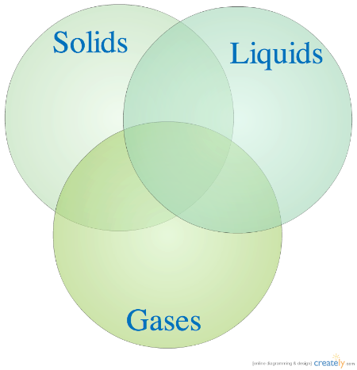
- _________ A 3.00 liter sample of neon gas at 0°C and 1.25 atm is compressed into a 1.00 liter container. If the pressure remains constant, what temperature will the container be?

- _________ What is the pressure exerted by 2 moles of oxygen at a volume of 500 mL at 20 °C?

- _________ How many moles of gas are in a 52 L sample collected at 220 Kelvin and .444atm?

- _________ Find the volume if a 2.1 L sample of a gas at 245 K and 2.1atm is changed to STP.

- _________ Find the new volume of a gas that changes 65 ml at 150 mmHg to 425 mmHg.

- Explain the relationship between each of the variables for the following gas laws:

  - Boyle’s Law
  - Charles’ Law
  - Avogadro’s Law

Chapter 13: Solutions

Vocab

- solute
- solvent
- saturated
- unsaturated
- supersaturated
- polar/non-polar
- soluble
- insoluble

- miscible
- immiscible
- solubility curve
- solution
- colloid
- suspension
- molarity

Be able to…
  - Identify mixtures as solutions, colloids, or suspensions
  - Explain colligative properties and relate to practice applications
    - salting roads, ice cream
  - Interpret a solubility curve
  - Identify substances as saturated, unsaturated, or supersaturated
  - Calculate molarity

Practice Problems:
- Interpret solubility curves:
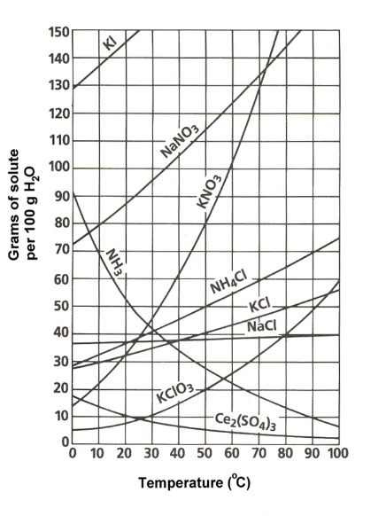
- What substance is most soluble at 20ºC?

- What substance is least soluble at 90 ºC?

- What is the solubility of KNO₃ at 50 ºC?

- How many grams of NaNO₃ can dissolve in 100 grams of water at 60° C?

- If 70g of KCl is dissolved at 70 ºC, is the solution saturated, unsaturated, or supersatured?
- _________ Calculate the molarity when 2 mol of CuSO₄ dissolves in 6L of water.

- _________ Find the molarity when 2.0 mol NaCl is dissolved in 2500mL of water.

- _________ How many moles of HCl is needed to prepare 1.5 L of a 0.010 M solution.

Chapter 15: Acids and Bases:

Vocabulary
- Arrhenius Acid
- Arrhenius Base
- dissociation
- titration

Be able to…
- Identify substances in chemical equations as acids or bases
- Identify the common physical and chemical properties of acids and bases
- Calculate pH of solutions

Practice Problems:
- Label the properties of acids and bases:
 | Acids | Bases
Dissociates into ____ ions
pH range?
Taste?
Feels?
Conducts Electricity?
Turns litmus paper red/blue
Turns Phenolphthalein clear/pink

- _________ Find the pH of a 1.0 x 10⁻³ M solution of HCl

- _________ Find the pH of a NaOH solution where H⁺ = [1.0 x 10⁻⁸]

Chapter 16: Reaction Rates

Vocabulary
- Collision Theory
- Catalyst

Be able to…
- Describe the two conditions for a successful chemical reaction
- Understand chemical reactions in terms of collision theory
- Be able to list and describe the 5 factors that affect reaction rates
- Interpret potential energy diagrams

Practice Problems:
- What are the conditions for a chemical reaction to occur?

- Explain how the following factors change reaction rates:

- surface area of a solid reactant

- concentration or pressure of a reactant

- temperature

- nature of the reactants

- presence of a catalyst

